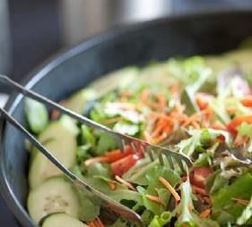
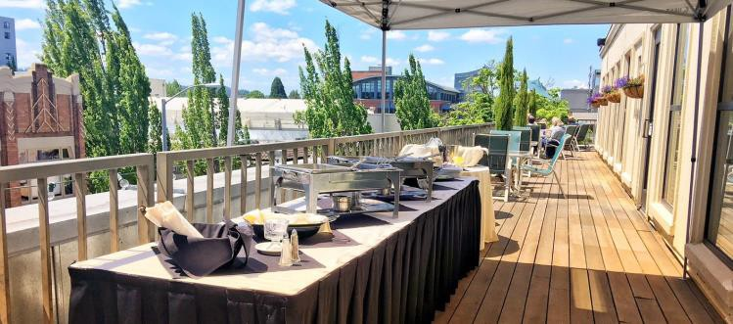
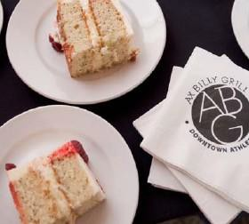
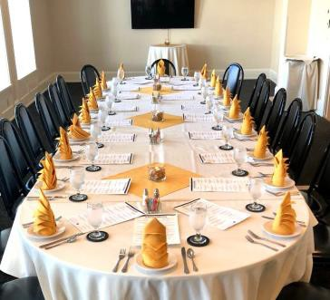
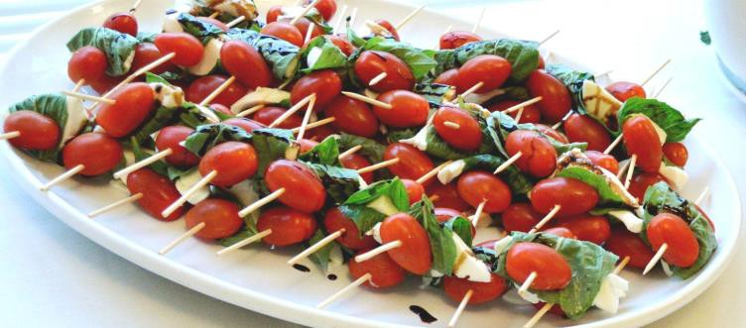

Catering Menu

BREAKFAST

early riser
assortment of fresh pastries
fresh seasonal fruits
yogurt and granola
hot regular and decaf coffee
assorted hot tea
orange juice

continental plus
assortment of fresh pastries
fresh seasonal fruits
scrambled eggs with cheddar cheese
bacon OR sausage
breakfast potatoes
hot regular and decaf coffee
assorted hot tea
orange juice

all American breakfast
assortment of fresh pastries fresh seasonal fruit
scrambled eggs with cheddar cheese
bacon and sausage breakfast potatoes
yogurt station
hot regular and decaf coffee assorted hot tea
orange juice

enhancements & upgrades
add bagels & cream cheese
add bacon
add sausage
add yogurt bar
waffle station

a twenty two percent service charge will be added to all charges, fees, and rentals. Prices subject to change based on market price

LUNCH
ALL SELECTION INCLUDE CHOICE OF ICED TEA OR LEMONADE, HOT BEVERGAE SERVICE AND AN ASSORTMENT OF HOUSE MADE COOKIES.

chicken Caesar salad station
past salad
seasoned grilled chicken
crisp romaine lettuce & red onions, freshly grated parmesan
house-made ceasar dressing & croutons
upgrade to Salmon

sandwich board
mixed green salad
sliced turkey , ham and roast beef
assortment of sliced domestic cheeses, wheat , sourdough and wraps lettuce , tomato , red onion , and pickles assorted condiments
add imported meats +
add imported cheeses +

fajita bar
mixed greens salad
marinated chicken with sautéed onions and peppers
seasoned beans and Spanish rice, tomatoes , onions , olives , cheddar cheese , sour cream, salsa, flour and corn tortillas
house – made tortilla chips
add marinated beef +

salmon & chicken duo
mixed greens salad and Caesar salad fresh caught salmon fillet and grilled chicken breast
wild rice pilaf and roasted potatoes pasta primavera
seasonal roasted vegetables

enhancements & upgrades
Upgrade dessert (ask for selection)
Add additional starch (rice, potatoes, pasta)
Upgrade to plated service

a twenty two percent service charge will be added to all charges, fees, and rentals. Prices subject to change based on market price.

DINNER
ALL SELECTION INCLUDE CHOICE OF ICED TEA OR LEMONADE AND AN ASSORTMENT OF DESSERT BARS.

Grilled Chicken or Skirt Steak

Chicken with choice of mushroom, piccata, or pesto sauce
Skirt steak with cherry red wine redux
smashed yukon or wild rice pilaf
roasted seasonal vegetables
ceasar salad or house salad pasta pomodoro
mozzarella & beet salad

Protein Duo
(pick 2) pork chop, chicken, or flank steak
smashed Yukon potatoes OR wild rice pilaf
roasted seasonal vegetables ceasar or house salad
bread & butter with butter bar pasta and panzanella salad
pasta primavera

Filet Mignon or Pork Tenderloin Carving Station
Filet mignon with gorgonzola butter
pork tenderloin with cherry wine redux smashed Yukon gold with garlic
OR wild rice pilaf
roasted seasonal vegetables ceasar or house salad
bread & butter with butter bar pasta and panzanella salad pasta primavera

enhancements & upgrades
Upgrade dessert (ask for selection )
Add additional starch (rice, potatoes, pasta)
Upgrade to plated

a twenty two percent service charge will be added to all charges, fees, and rentals. Price subject change based on market price

SPECIALTIES
ALL SELECTION INCLUDE CHOICE OF ICED TEA OR LEMONADE AND AN ASSORTMENT OF DESSERT BARS.

Northwest
salmon
flank steak
Brussel sprouts with Sirach garlic aioli and red onions yukon mashed potato
roasted season vegetables
house and ceasar salad coos coos salad
bread and butter bar

Mexican
cheese, chicken, beef or pork
taco bar (soft shells, protein choice, salsa, lettuce, sour cream enchiladas
refried beans
black bean salad tortilla salad Spanish rice chile relleno
add shrimp $3/pp
add carved prime rib $9/pp

enhancements & upgrades
Upgrade mixed greens salad to Caesar salad Upgrade dessert (
ask for selection )
Add additional starch ( rice , potatoes , pasta )
Upgrade to plated

a twenty two percent service charge will be added to all charges, fees, and rentals. Prices subject to change based on market price

HORS D'OEUVRES

CAPRESE SATAY
Organic cherry tomatoes , mozzarella , fresh basil , topped with balsamic reduction

ASSORTED MINI QUICHE
Three cheese quiche , Spanish quiche , ham quiche .
Served hot

SPANAKOPITA
Spinach and Asiago cheese wrapped with filo dough

MEATBALLS
Served hot with barbecue sauce

BRUSCHETTA
Smoked salmon canape , pickled red onions and capers

STUFFED MUSHROOMS
Cremini mushrooms stuffed with herb goat cheese

Premier appetizers

CHICKEN SKEWERS
Grilled teriyaki chicken , sesame seeds , green onions sub beef

CRAB CAKES
One ounce crab cakes with lemon aioli

AX BILLY SLIDERS
Signature sliders with aioli and cheddar cheese

SHRIMP COCKTAIL / SERVES 10
Chilled jumbo prawns , cocktail sauce , lemon wedges

a twenty two percent service charge will be added to all charges, fees, and rentals. Prices subject to change based on market price

Social Platters
serves 25

HOUSE-MADE HUMMUS
Fresh in-house wood oven focaccia bread, celery and carrots , assorted olives

SPINACH ARTICHOKE DIP
House - made spinach - artichoke cream cheese dip , fried pita chips

FRUIT TRAY
Assorted seasonal local fruit

a twenty two percent service charge will be added to all charges, fees, and rentals. Prices subject to change based on market price

HORS D'OEUVRES

Reception Trays
serves 50

CRUDITE DISPLAY
Selection of fresh vegetables , pickled vegetables and herbs Served with peppercorn ranch

SMOKED & CURED MEATS
Smoked turkey, ham, roast beef , prosciutto , and salami . Assorted crackers and house bread .
Stone ground mustard and garlic aioli

SMOKED SALMON
House - made smoked salmon , cream cheese , capers , onion Served with assorted gourmet crackers

CHEESE & CHARCUTERIE
Selection of local and imported cheeses and meats . Garnished with grapes and gourmet crackers

À L A C A R T E & S N A C K S

freshly baked cookies doz assorted house-baked pastries doz

chips, salsa, and guacamole
nuts, pretzels and chips
house- made potato chips
string cheese, protein bars and fruit

a twenty two percent service charge will be added to all charges, fees, and rentals. Prices subject change based on market price

BEVERAGES

n o n - a l c o h o l i c
ALL BEVERAGES CHARGED ON CONSUMPTION

COFFEE SERVICE /GAL
Includes local & organic , regular coffee , decaf Coffee , assorted Teas

BREAKFAST /GAL
Your choice of organic orange Juice or apple Juice

INDIVIDUAL BEVERAGES $3/EA
Coca Cola , Diet Coke , Sprite , Root Beer , Ginger Ale , Bottled Water

REFRESHMENTS /GAL
Your choice of ice tea , lemonade , or strawberry lemonade

a l c o h o l

BOTTLED BEER | KEG BEER
Domestic | Domestic
Microbrew | Microbrew
Imported | Imported

WINE SELECTIONS House Wine
Select Wine
Premier Wine
LIQUOR SELECTIONS

WINE CORKAGE FEE - $ 25 / BOTTLE
House Labels
Premium Labels
Top Shelf Labels

KEG TAPPING FEE:
$ 200 PER 1 / 6 BARREL
$ 275 FOR 1 / 2 BARREL HOSTED
BAR OR CASH BAR AVAILABLe

a twenty two percent service charge will be added to all charges, fees, and rentals. Prices subject to change based on market price

